  
  
  
**Parallel and Distributed Computing  
CSE4001**

***Lab Assignment 1***

Slot : L21+L22

Name : Kulvir Singh

Register Number : 19BCE2074

**Question 1 : Parallel programming using multithreading with different variants as given in the class1 ppt**

***AIM and PROCEDURE :***

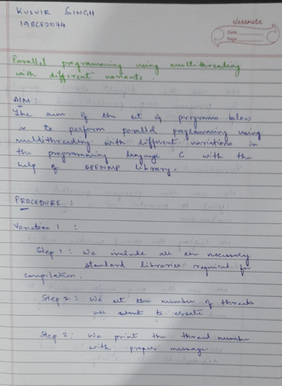

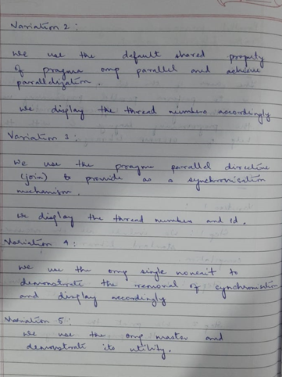

**Variation 1 : Creating 5 threads**

Code Screenshot

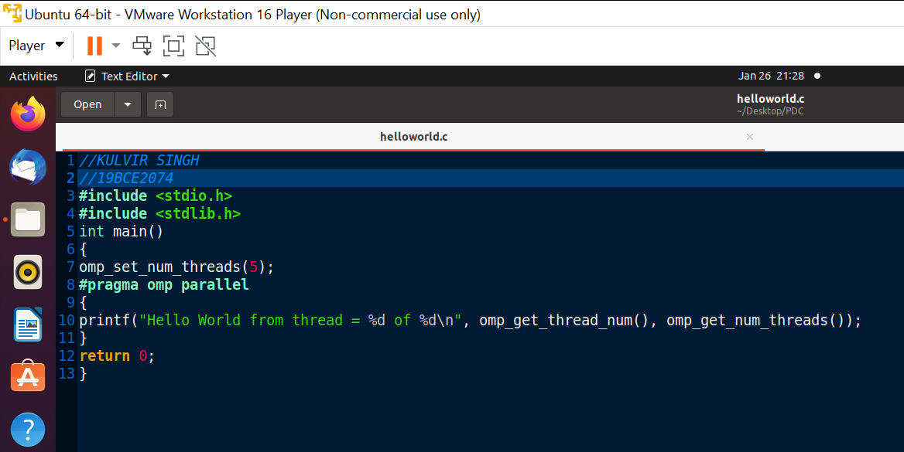

Output Screenshot

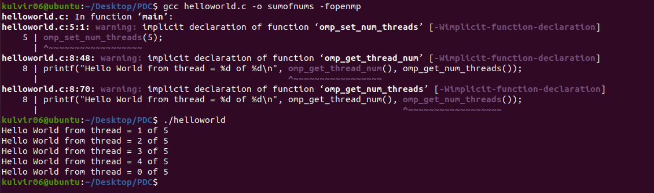

**Variation 2 : Demo of #pragma omp parallel default (shared)**

Code Screenshot

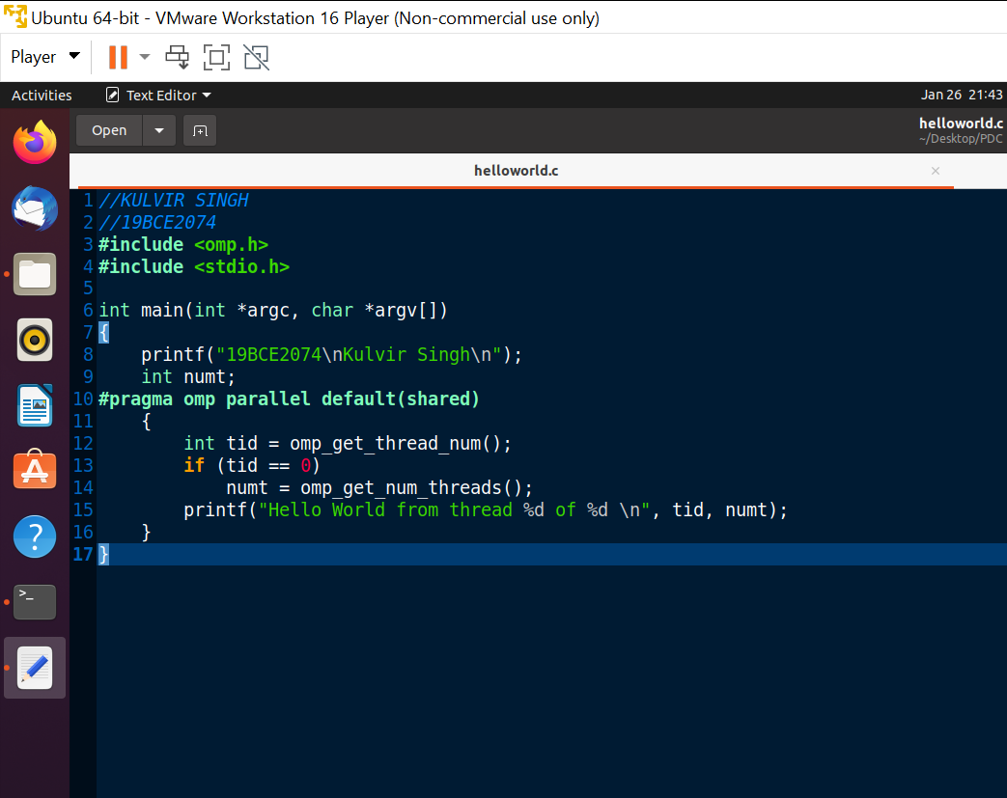

Output Screenshot

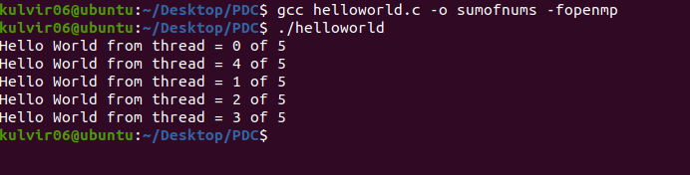

**Variation 3 : Demo of parallel directive join**

Code Screenshot

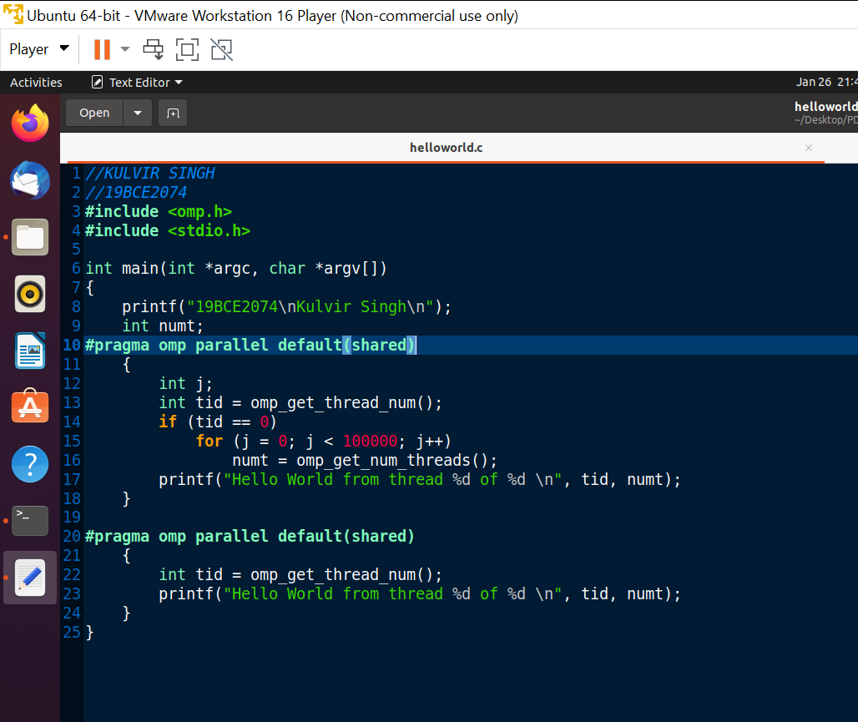

Output Screenshot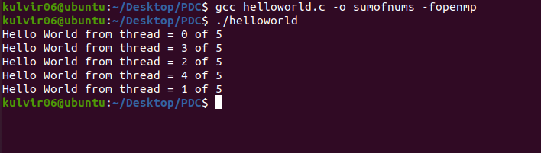

**Variation 4 : Demo of #pragma omp single nowait**

Code Screenshot

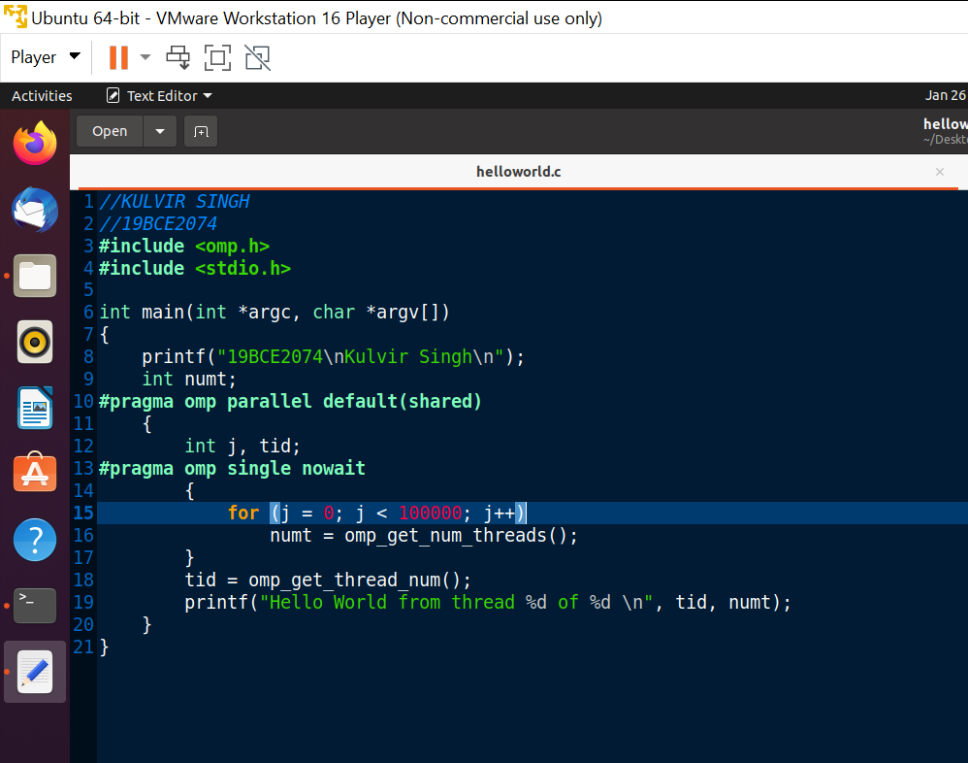

Output Screenshot

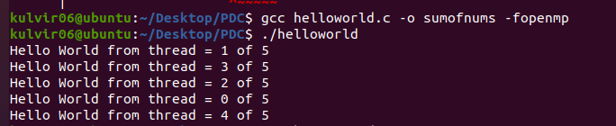

**Variation 5 : Demo of #pragma omp master**

Code Screenshot

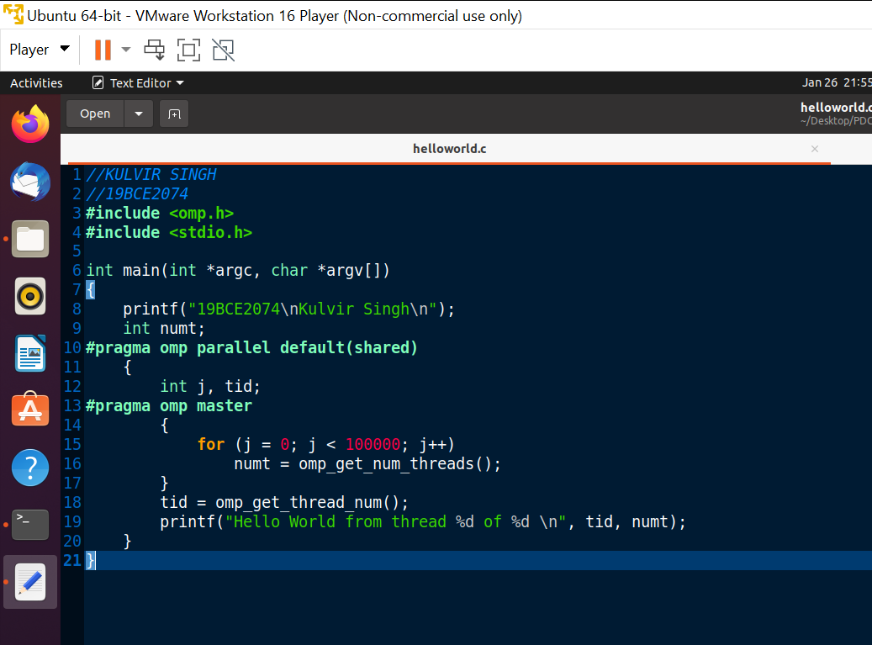

Output Screenshot

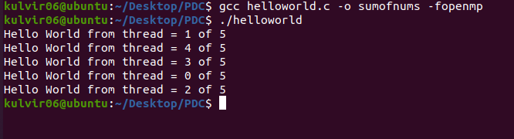

**Conclusion :**

The 5 variations of the parallelization using multithread demonstrate clearly how parallel computing works with the help of various threads and their execution in C programming language using OPENMP.

**Question 2 : Parallelizing Sum of the digits program using for looping**

***AIM and PROCEDURE :***

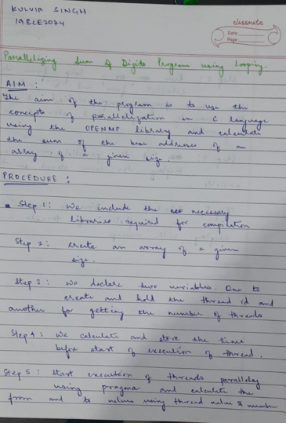

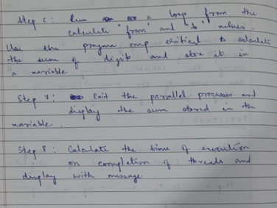

***Code Screenshot***

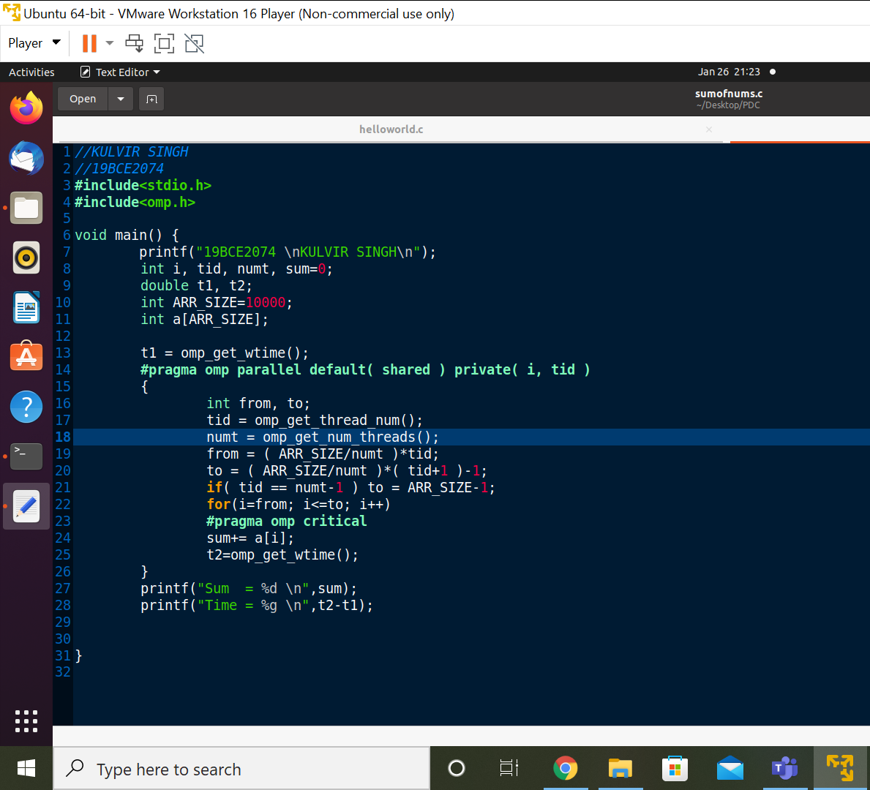

***Output Screenshot***

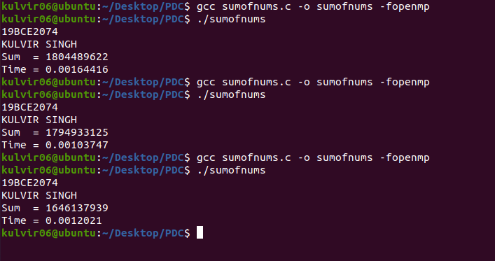

**Conclusion :**

The program accurately calculates the sum of the digits using the concepts of parallelization and uses the OPENMP module to achieve the same. The time calculated for the execution is optimized as compared to serial execution.